Leap of Faith-I’ll be your net
I'm Rosemary DeTrolio, founder of Hands of Light by Rosemary in New Jersey. This podcast is your space for spiritual insights, tips, and inspiring interviews with gifted healers from around the world. Tune in and explore the journey.
2026
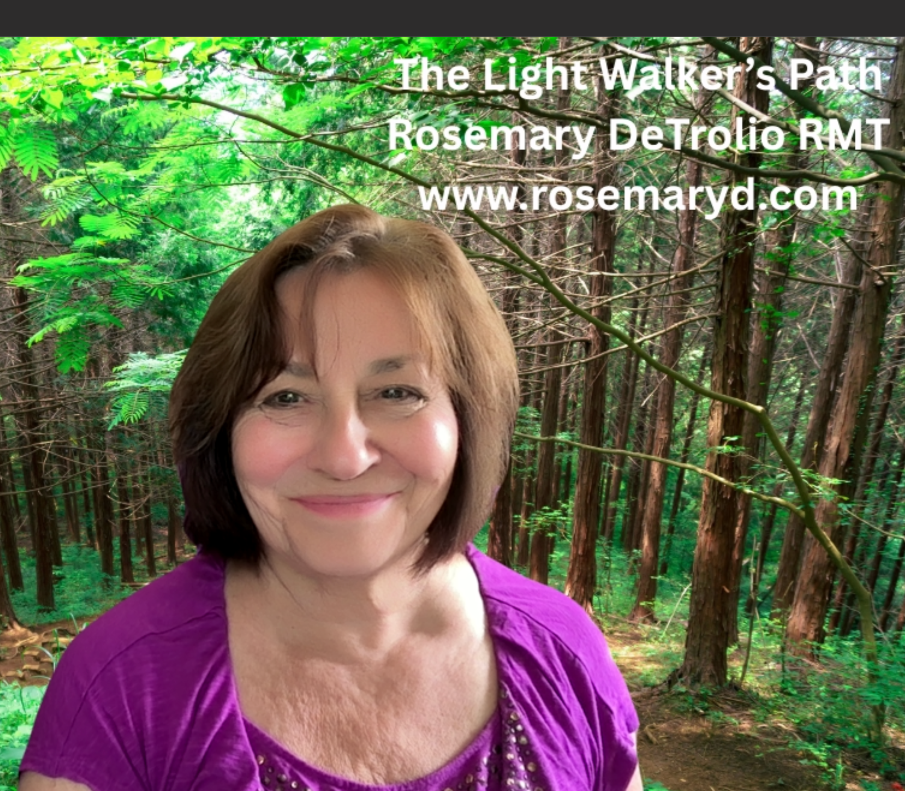
When the solution is simple, God is answering. -- Albert Einstein
God is a comedian playing to an audience too afraid to laugh. -- Voltaire [Francois-Marie Arouet]
Don’t wait around for a sign—your body holds the wisdom you need. When you act on an idea, even a small step often leads to the next one naturally.
Your intuition is already within you, ready to guide you once you learn how to connect with it. One of the simplest ways to start is by developing body awareness. Rosemary is a keynote speaker who teaches this skill not only to healers, but to midlife professionals struggling with decision making.
Here’s a practice: Take a few deep breaths and allow yourself to relax. Then, imagine a situation you're considering. Notice how your body feels. If you sense ease or openness, that’s alignment. If tension or discomfort arises, it may be a sign that something is off. Check in with your intention—your body never lies.
Fear is a liar.
Your fear will derail great ideas. Fear will grumble and judge you. Don’t give it power.
Never be limited by someone’s viewpoint, even if that voice is your own fear.
Your vision will become clear only when you look into your heart. Who looks outside, dreams. Who looks inside, awakens. -- Carl Jung
Self-awareness is the gateway to Universal wisdom. Our higher self—the most elevated part of our soul—is naturally attuned to guidance from angels and spiritual allies. This divine insight is always available, but often drowned out by the noise of constant mental chatter.
Moments of clarity, sudden insight, inner nudges, or visions that prompt change are all inspired messages. However, fear and worry can block these sacred signals.
Free will is always at play—how we use it determines whether we align with higher guidance or move away from it. The choice is ours.
Do People forget the plan or mission they were born here to do?
Yes! Déjà vu and meaningful coincidences, known as synchronicities serve as gentle reminders that you’re back on the right path. They’re like shimmering stones marking the trail, guiding you forward.
When we awaken to this awareness, we can make powerful shifts that realign us with our true purpose. Spontaneous healing, a sudden leap in consciousness, or the birth of a new direction can unfold almost effortlessly.
Your thoughts are powerful. Be mindful of your words and your thoughts.
Sound waves are invisible, but they exist. Your words have a sound imprint.
Thoughts are powerful—they create energy.
When I first heard this, it shifted everything. I began paying closer attention to the thoughts I entertained and consciously chose which ones to release. No thought is forbidden, but once you're aware, you gain the power to let go of what no longer serves you.
Our thoughts shape energetic patterns that ripple into the collective field. Since we're all connected through energy and vibration, what you think truly matters.
Want to go deeper?
Explore my podcast, join a workshop, or book a private session with me, Rosemary. PODCAST LINKS
Curious about a service you saw on my site?
Schedule a free 30-minute discovery session. Find it on my website. This isn’t a guidance session, but it’s the perfect time to ask questions about my offerings, workshops, or courses. Explore my guidance books. Interested in learning more? info@rosemaryd.com.
My books
https://www.amazon.com/stores/author/B005JKCMKC
Guidance for Change via Zoom
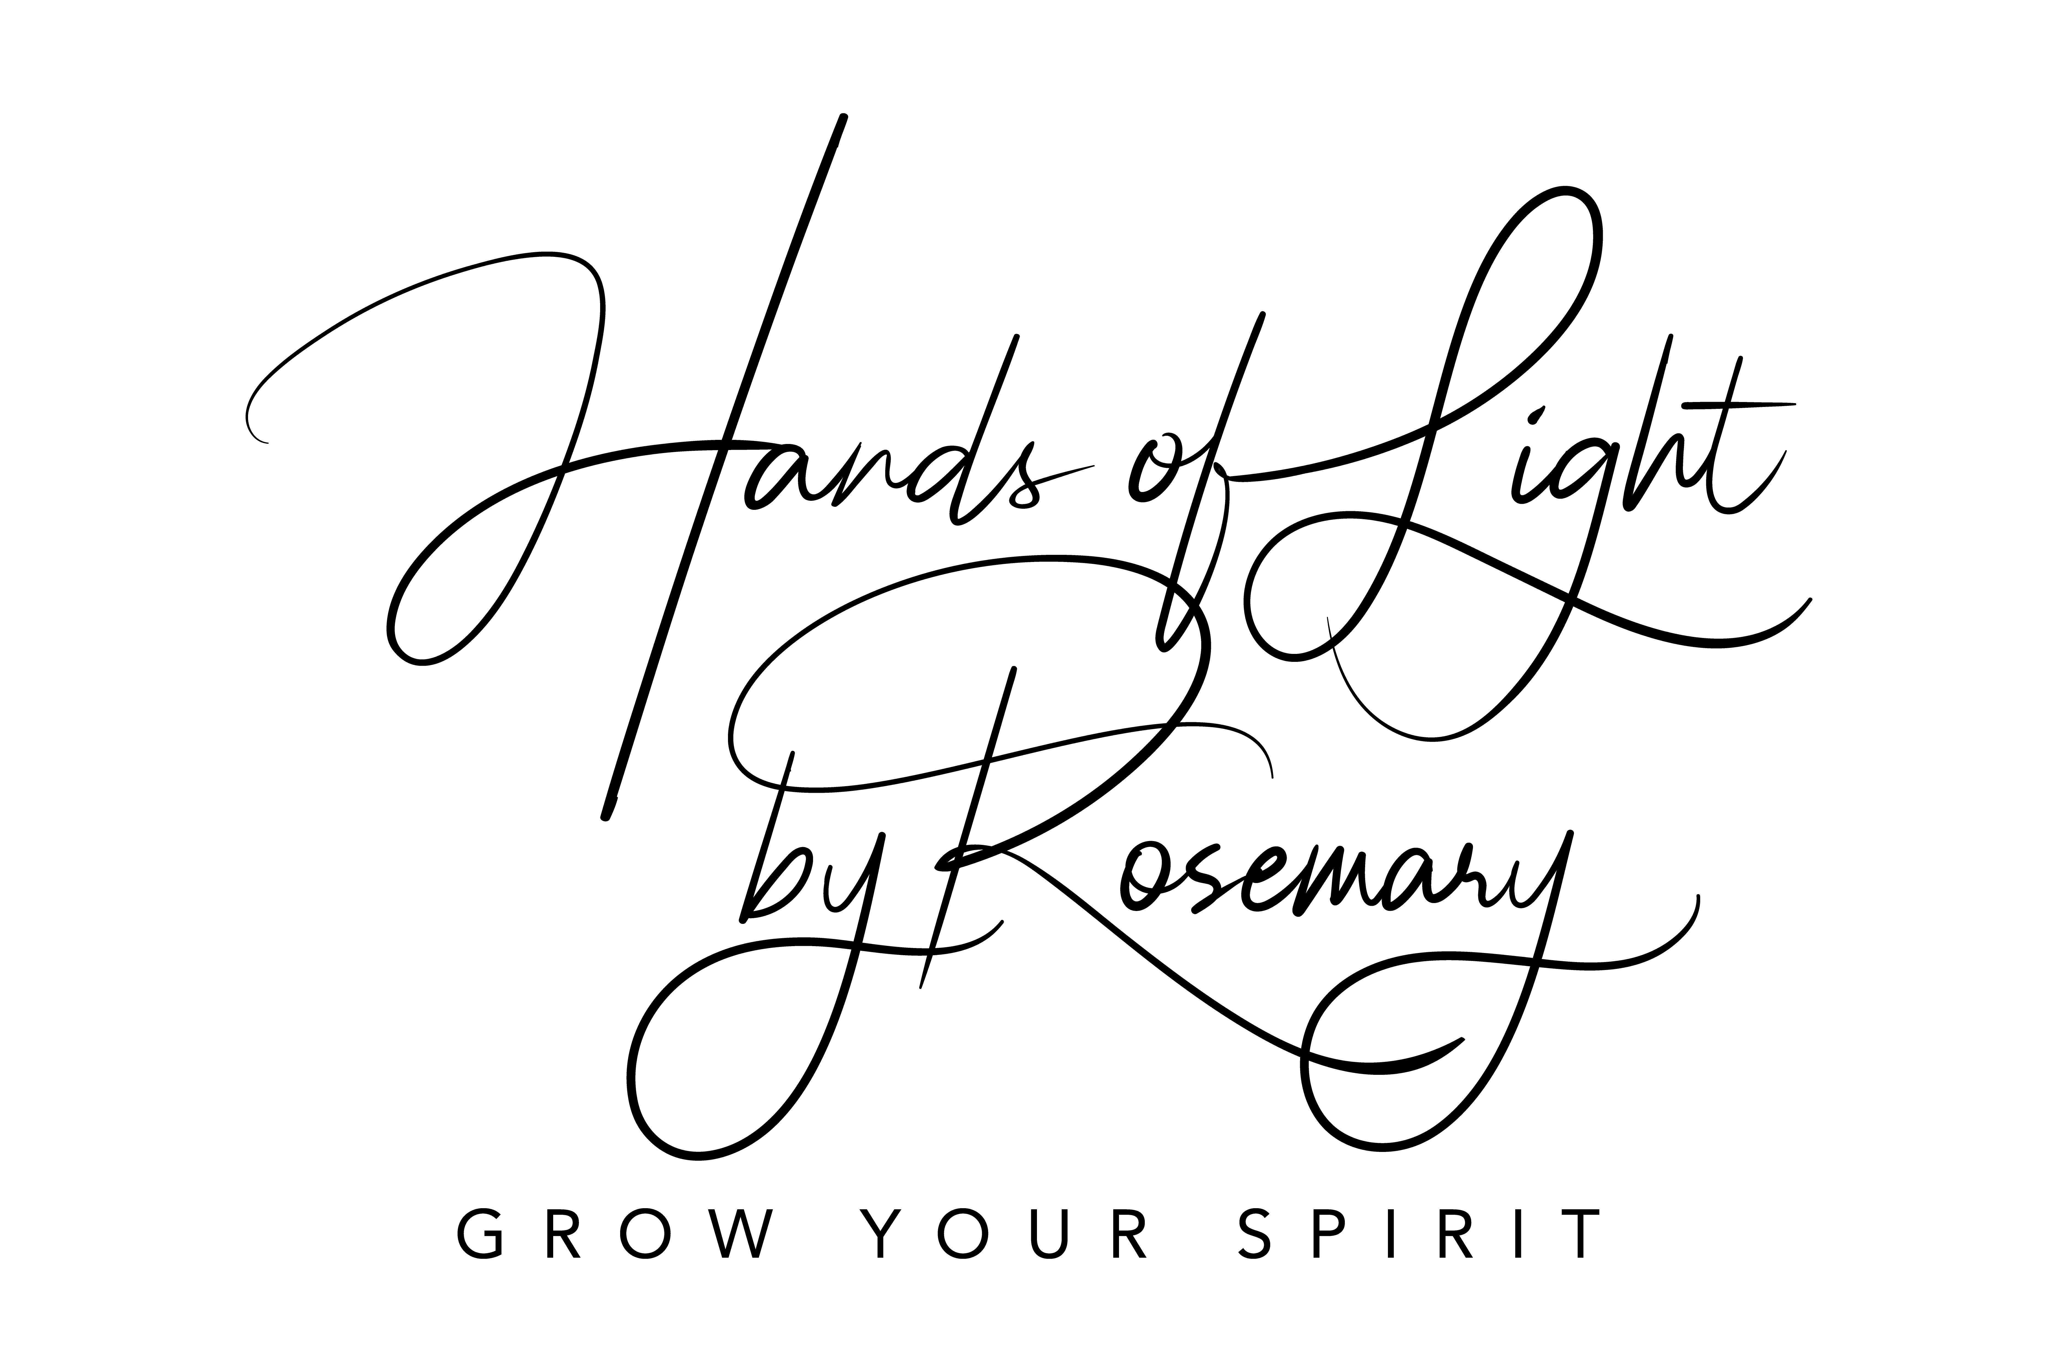

Do you have a comment, suggestion, or other? Email Rosemary.
info@rosemaryd.com
Got cheers? Can give a 5* review after a service you enjoyed?
I welcome google reviews.

