Reiki is a relaxing session that calms the parasympathetic nervous system allowing the body to heal itself. Reiki has no contraindications and can do no harm. Most people feel relaxed and lighter after a session, sometimes a person may detox an underlying condition. Though rare, a healing crisis may occur and last a day or two. This detoxifies and rebalances your body. Drink water and rest to help your body rebalance, especially if you’ve been under stress or have had an illness.
Contact me with any concerns, but trust that this is a temporary flare up that will pass in a day or two.

I suggest three sessions within a period of a month in order to receive the most benefit in a quicker amount of time.

Reiki is taxable in NJ. Your price already includes state tax.
If a person is under 18, a parent or guardian must be present during the session.
Please print clearly
First/Last_______________________________________________________

Cell Phone __________________________________________________
Email_____________________________________________________

Mailing address__________________________________________

City, State, Zip___________________________________________

Emergency Contact Name________________________________ cell_____________

How did you hear about us?(circle) FB Web search advertisement client referral

Have you ever had a Reiki session before? Y
Are you sensitive to fragrances? Y N

What are your common areas of pain or tension? (x off areas)
Any concerns or conditions?

Make an X on areas of pain.

Front of the body Back of the body
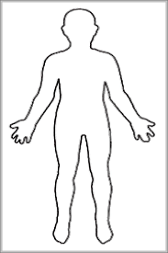

Are you comfortable with touch? Y N

